Can you find the words goat and goats? Highlight the words.

Goats can be found all over the world.
There are over 300 types of goats.
You can find goats in the wild, on a farm, or as pets!
Goats were the first animal to be used by humans for milk.
People eat and drink milk products from goats.
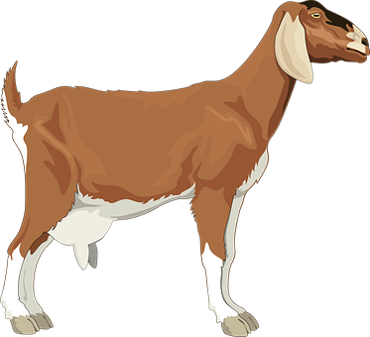
A female goat is called a doe or nanny.
The male goat is called a buck or billy.
A baby goat is called a kid.
A group of goats is called a herd.
Goats are very friendly creatures.
If goats are left alone for long periods of time, they can get very lonely.
