Leeview House
Milltown
Co. Galway
Mr Joe Bloggs
Bloggs Company
Kilkee
Co. Clare

Saturday, 3rd December 2016

Dear Mr Bloggs,
I am applying for the Office Clerk job advertised on 30th November. I enclose my CV for your information.

As you can see, I have had much experience in office environments, and I have work with many different types of people. I believe I could fit easily into your team. I am a hard worker with great ideas and I'm flexible. I’m keen to work for a company with a great reputation like Bloggs.

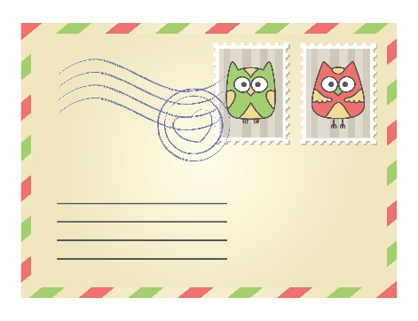
I look forward to hearing from you.

Yours faithfully,
……………………………………
Print your name here

