5 a) Note to tutors: Copy and email to students the message below. Attach the file queen_mary and queen_mary2. (Make sure the students know this is not real!)
…………………………………………………………………………………………………

Subject: Cruise

Hi Students,

We have booked a world cruise on the QE2 for our computer class.

Please find the attached photos.

Please let me know if you wish to attend this trip. Please note that it will not purely be a holiday as we have to keep up our IT skills. You must bring your laptop with you on the cruise. It would be a kind gesture if students clubbed together and paid for the tutor.
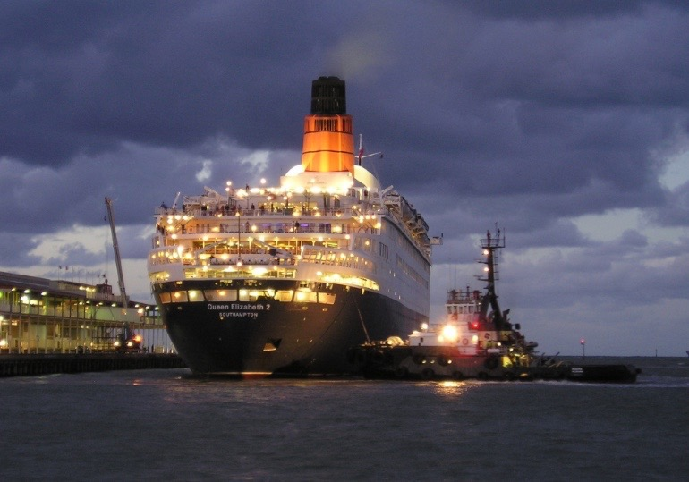
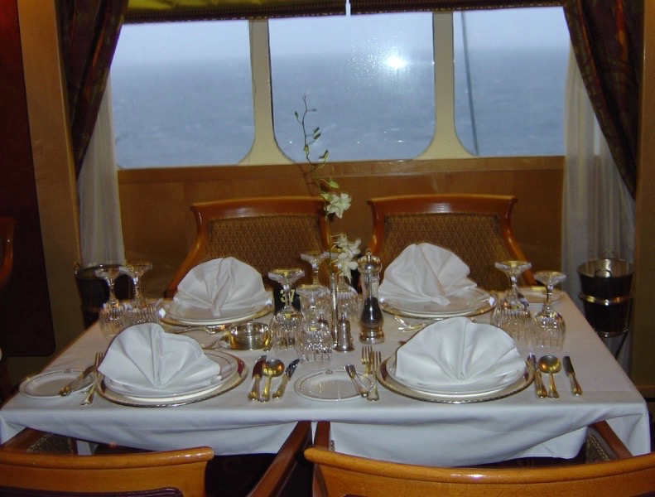
Kind regards

5b) Note to tutors: Copy and email to students the message below. Attach the file men’s form and women’s form.
Subject: TV Show

…………………………………………………………………………………………………

Hi Students,

Please let me know if would be interested in taking part in the dating show 'Take me out'. Relevant forms are attached. Please only print these forms if you intend to go to the show.

Kind regards

5c) Note to tutors: Copy and email to students the message below. Attach the file zoo_map.

…………………………………………………………………………………………………

Subject: Zoo Trip

Hi Students,

The outing to Dublin Zoo will take place on Saturday the 20th October.

We will be leaving Dublin Bus in O’Connell Street at 9.30 a.m.

Please indicate

See the attached map. In your reply, attach a picture of an animal you would like to see at the zoo.

Kind regards

(Attach image of zoo)

